Clemson University

Homographies and Fundamental Matrices
Assignment 5, ECE 877
Ujwal C Naik
Assignment Number 5

Report for the 5th assignment for Computer Vision – ECE 877.

Introduction:
In this assignment we compute the homography between an image and the ground plane and using this information we are able to unwarp the image to a top-down view which gives us a better perspective of the scene. Further, we are able to determine the real world length of a line lying in the image.
For the second part of the assignment we have computed the fundamental matrix for a pair of uncalibrated stereo images. The normalized eight point algorithm was used to compute the fundamental matrix.

Method:
The method followed for implementation of the top-down/bird’s eye view mapping is as follows:
- Load the correspondences: In this step we load the correspondences between the points on the image and their desired mapping points.
- Calculation of the Homography Matrix: Using the points on the image and the corresponding points on the desired un-warped image we were able to calculate the desired homography matrix. Note: more than eight points are required for the algorithm to work satisfactorily.
- Un-warp the image to the top-down perspective: Using the calculated homography matrix we un-warped the image to the desired top-down view.
- Finding the length of a line in the image: We have to find the length of a line drawn by the user by clicking on 2 random points. In this case the mapping is done such that each pixel represents an inch and the calculation is reduced to counting the number of lines.
The method followed for calculation of the fundamental matrix was as follows:
- We calculated the normalizing transformation matrices T and T’ using the set of correspondences provided.
- Using the normalizing transformation matrices the coordinates were normalized.
- Using the normalized coordinates we calculated the fundamental matrix:
- Construct A(46,9) using the correspondences given.
- Compute the SVD of A.
- Get the right most singular vector of A and reshape f into a 3x3 matrix using these values.
- Compute the SVD of f.
- Set the value of Sigmaf(3,3) = 0 to ensure that the rank is 2.
- Now the fundamental matrix is given as U*Sigmaf*Vt.
- Use the fundamental matrix to calculate the position of the epipoles in both the images.

Algorithm:
The algorithm for top-down view transformation is as follows:
- Load the correspondences.
- Calculate the homography matrix using normalized DLT.
- Use the homography matrix to un-warp the image to the desired top down view.
- Once the top-down view is obtained calculate the length of the user defined line.
The algorithm for calculating the epipolar lines:
- Compute the Normalizing transformation matrices T and T’.
- Normalize the coordinates using the transformation matrices.
- Using the eight point algorithm compute the fundamental matrix.
- Transform the matrix back to the original coordinate system.
- This simple matrix multiplication of the homogeneous coordinate with the fundamental matrix gives us the desired epipolar in the corresponding stereo image.

RESULTS
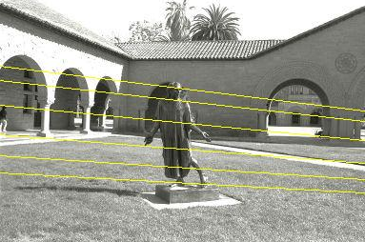
Image2

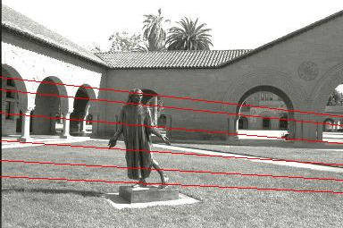
Image 1

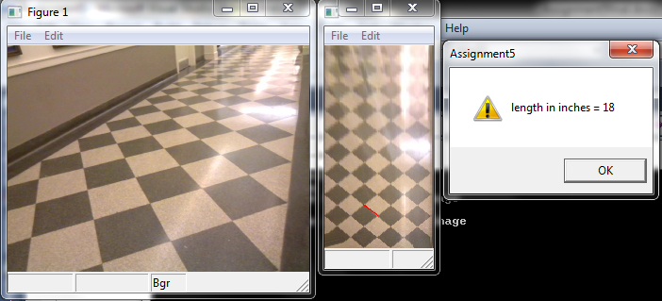
Bird’s eye view.


Conclusion
The homography can be used to map image coordinates in a unique way so as to gain a new perspective on the image. Using the homographies we can also gain more information on the image applications of homographies are of tremendous use in fields like robotics.
Epipolar geometry lets us find the focal point of the camera being used and it can be used in applications such as detecting the direction of motion. It is also possible to detect the motion parallel to the image plane. Epipolar geometry has many applications in topics such as 3D reconstruction.
.

